17.126: a) The rates are:
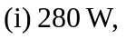
The total is 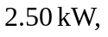with the largest portion due to radiation from the sun.
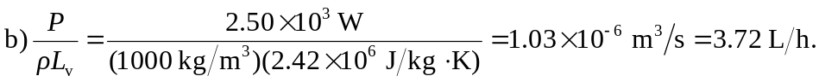

c) Redoing the above calculations with 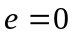 and the decreased area gives a power of 945 W and a corresponding evaporation rate of 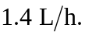 Wearing reflective clothing helps a good deal. Large areas of loose weave clothing also facilitate evaporation.

